Scli3r/Postprocessor SetUp
Last updated: 10/30/217 by Maria Rodriguez (mr@cellink.com)
If your g-code is not acting as you would expect, it is most likely a postprocessor issue. The postprocessor will translate your Gcode to your bioprinter’s specific language. It is a python file, so you may need to install python on your computer. Instructions to do so can be found on Chapter 6 of the user manual.
To address the issue follow the steps below:
- On Slic3r, go to Print Settings and select a setting -> Output options -> Post-processing scripts.
- Add the path to the file postprocessot.py. It should look like the picture below, except you are adding your own path. Usually, the postprocessor comes inside the folders INKREDIBLE + -> software.
- Save the changes by clicking the save icon next to the setting you chose.
- Repeat the process for all your Print Settings, making sure to save each of them.
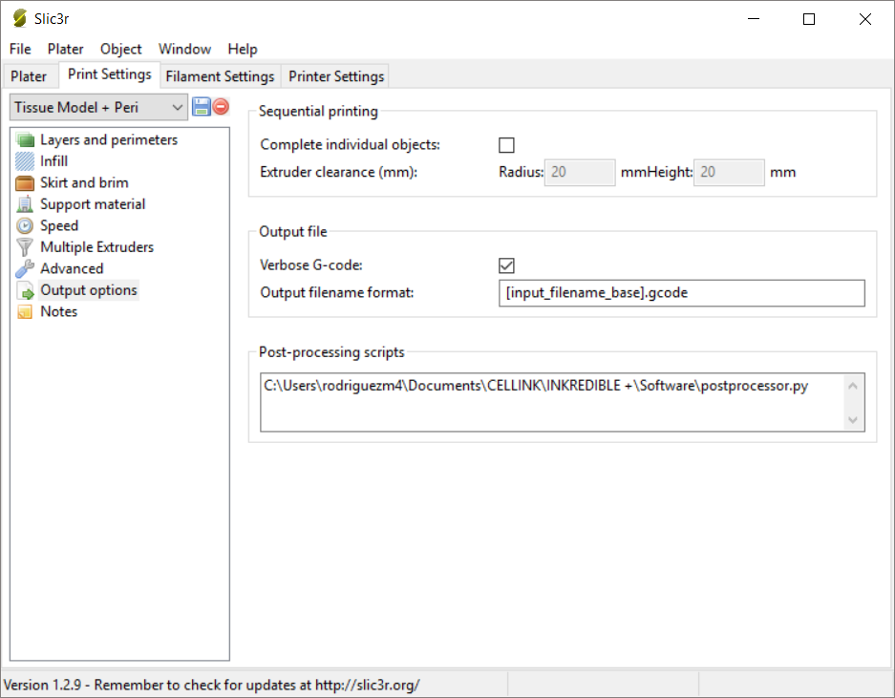
To verify that you have done all the previous steps correctly, verify that when you slice a file on Slic3r, your Gcode starts with the following script: “Post processed by INKREDIBLE post processor”.

